**Trek 2024 - Kaysville Utah East Stake**

**“Remember Them, Remember Him!” - Packing List**

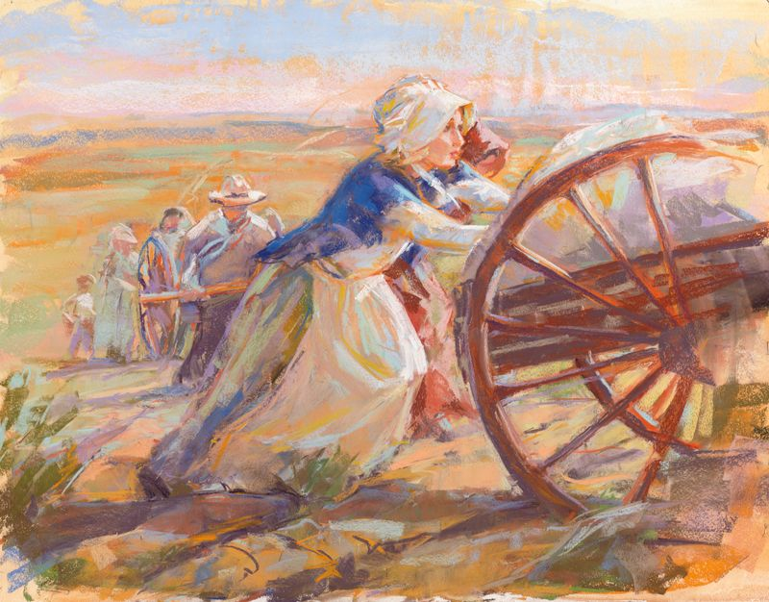

**Pioneer clothing**

**Sisters:**

* 2-3 complete sets of pioneer clothing. Including a complete pioneer dress about 6 inches from the ground in length. **No denim**.
* Or 2-3 long pioneer skirt about 6 inches from the ground with a modest long sleeve top. **(No t-shirts)**
* Western style hat or wide brimmed floppy hat with chin strap to keep it from blowing away, or a pioneer bonnet.
* 2-3 pairs of bloomers or lightweight knee length shorts to be worn under the pioneer skits. (Scrubs work well – helps avoid chafing and bug bits. Do not bring leggings to wear under a dress as it will keep the heat in.
* 1-2 aprons with pockets.

**Brethren:**

* 2-3 pairs of pioneer style pants – Dockers type, light colors are best. **No denim, camouflage or sports type pants.**
* 2-3 shirts – long sleeve button up cotton shirts, light colors are best**, no t-shirts**.
* 1 western style hat with chin strings to keep it from blowing away or a wide brim floppy hat. **No beanies, army hats or baseball caps.**
* Vests – optional.
* Suspenders – optional.
* Levi or denim jeans are **not allowed.**

**Obtaining your “Pioneer Clothing”:**

* Each ward has a “clothing expert” called to assist you. Your Bishopric can direct you to that person.
* Outlines how making your clothing can be found on **Rememberhim2024.com**

**What to Pack: For everyone -**

* **Shoes** – 2 pairs (1 should be water shoes, no flip flops). Shoes should be sturdy athletic shoes. They can be cross-trainers, trail or running shoes. You need good tread on the bottom of your shoes. You can wear hiking shoes but it is not necessary. PLEASE, bring well broken in shoes before trek.
* **Jacket** – Lightweight but warm or a sweatshirt. (This can be rolled into a sleeping bag to save space)
* **Sleeping bag** – Warm, good quality. (It can get into the low 40’s degrees at night)
* **Small pillow** – Space is limited!
* **Sleeping pad** – Small backpacking pad, (NO foam pads). Your sleeping bag, small pillow and the sleeping pad must fit into a garbage bag that **will be supplied by the Stake**.
* **Work gloves** – 1 pair, warm, soft leather or inexpensive work gloves with non-slip grips for handcart pulling.
* **Warm pajamas** – 1 set, modest, to sleep in (it does get cold at night).
* **Rain Poncho** – or Rain Jacket – It may rain!
* **Socks** – 4 pairs. 2-3 pairs should be wool; liners are optional but a great idea. To prevent blisters use a rayon or polypropylene sock (or nylon) next to the skin and a wool sock on the outside. Cotton socks on the skin can increase blistering.
* **Underclothing** – 3 sets.
* **Small flashlight** – with NEW batteries.
* **Sunglasses –** Bright sunny July days are hard on the eyes.
* **Large Ziploc bags** or plastic grocery bags to store clean and dirty clothes.
* **Reusable sturdy water bottle** - there will be water bottle holders on the handcarts.
* **Scriptures** – Small size, paper – You will not have electronic devices.
* **6 – Gallon bucket** ideally with a screw-on lid. Making a padded seat is optional. See **Rememberhim2024.com** for ideas how to make a pad for your bucket. We will be using them as “chairs”!

**Personal items – For everyone:**

* **Small hair comb** or brush
* **Toothbrush, floss and toothpaste**
* **Deodorant**

**Personal items continued -**

* **Small hand towel**
* **Sun block SPF above 30 and Sun block** lip balm (common problem is sunburned lips!)
* **Sanitizing tissues or wet wipes** (great for end of the day “cleaning up”… no showers!)
* **Hand Sanitizer**. (there will be areas to wash your hands frequently, but a small bottle for personal use is ideal)
* **Chafing powder/cream**. Common problem from the heat and prolong walking.
* **Sanitary supplies as needed**.
* **MEDICATIONS as needed**. (The Medical team has a secure “cool temperature” area to store your medication, and if needed refrigerated areas. Talk with the medical team at the check in on July 9th or 10th.) Our medical team will be supplied with medical items; however you may want to bring a small first aid kit with **Band-Aids and antibiotic ointment.**

**What to pack inside your 6-gallon bucket:**

* **Pioneer clothes** (Best to have a separate bag for “clean” vs. “dirty”
* **Water shoes** with a Ziploc bag/sack to store them when they are wet
* **Socks**
* **Underclothing**
* **Small flashlight**
* **Personal items** (Hygiene items, toothbrush, etc.) Ideally, stored in a Ziploc bag.
* **Poncho**.
* (Your sleeping bag, small pillow and backpacking pad will be **put into a bag provided by the Stake** when you check in the night before Trek at the Stake Center on July 9th)

**You will be given a Side Day Pack by the Stake when you check in at the Stake Center**. You will **not** need a backpack. In that Side Day Pack you will put the following:

* **Work gloves**
* **Wet wipes or tissue**
* **Sunglasses, Sun Blocking Chap stick, Sun Screen/block SPF 30 or above**
* **Rain poncho**
* **Water bottle**
* **Journal and pen (this will be provided by the Stake)**
* **Insect repellant and Water shoes with Ziploc bag.**

**WHAT NOT TO PACK:** Personal music players, game system, electronic devices, matches, phones, lighters, aftershave, hairspray, gel, makeup or perfumes (they attract bugs that bite.)

**Trek – Where Heaven and Earth coexist for a short period of sacred time! So Fun!!!**